NAAN MUTHALVAN PROJECT

Analysing Housing Prices in Metropolitan Areas of India

TEAM:

1. S.Jasmine

2. K.Thaslima

3. R.Krishnaveni

4. S.Parameswari

Introduction

**Overview**

House price prediction in a metropolitan city in India is a valuable solution for potential home buyers, real estate agents, and investors. By leveraging historical sales data, property details, and location-specific information, a predictive model can accurately estimate house prices. The model's scalability, real-time updates, user-friendly interface, and transparency ensure it meets the needs of stakeholders. Integration capability, data privacy, and cost-effectiveness are also important considerations. By addressing these requirements, the prediction model provides reliable insights, empowering stakeholders to make informed decisions in the fast-paced real estate market.

**Purpose**

The high demand for housing in these cities leads to a rise in property prices. Limited supply: The supply of housing in metro cities is limited due to the scarcity of land, strict building regulations, and lack of affordable housing option. This further drives up the cost of houses. Location: Houses located in.

**Problem Definition & Design Thinking**

**Empathy map**

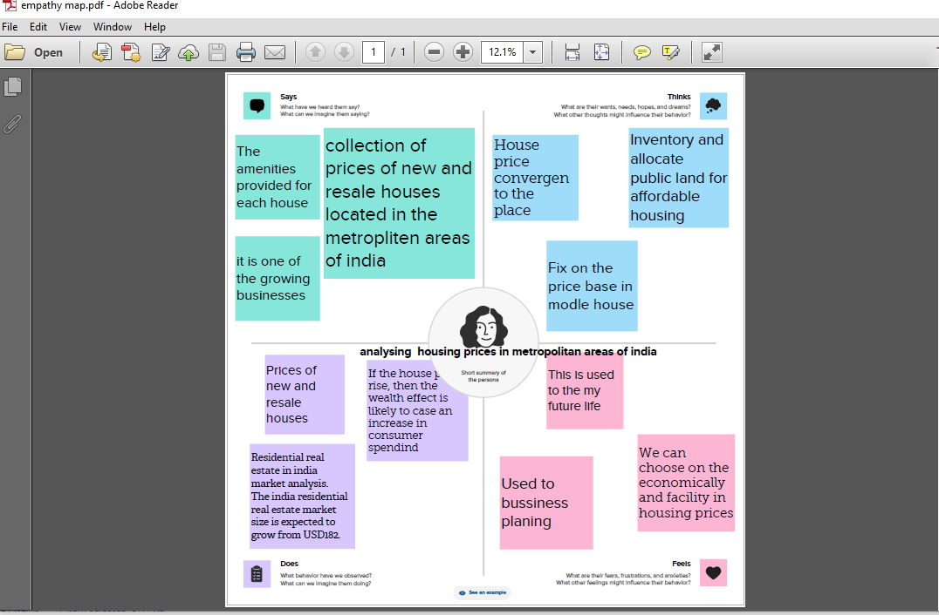

**Ideation & Brainstorming Map**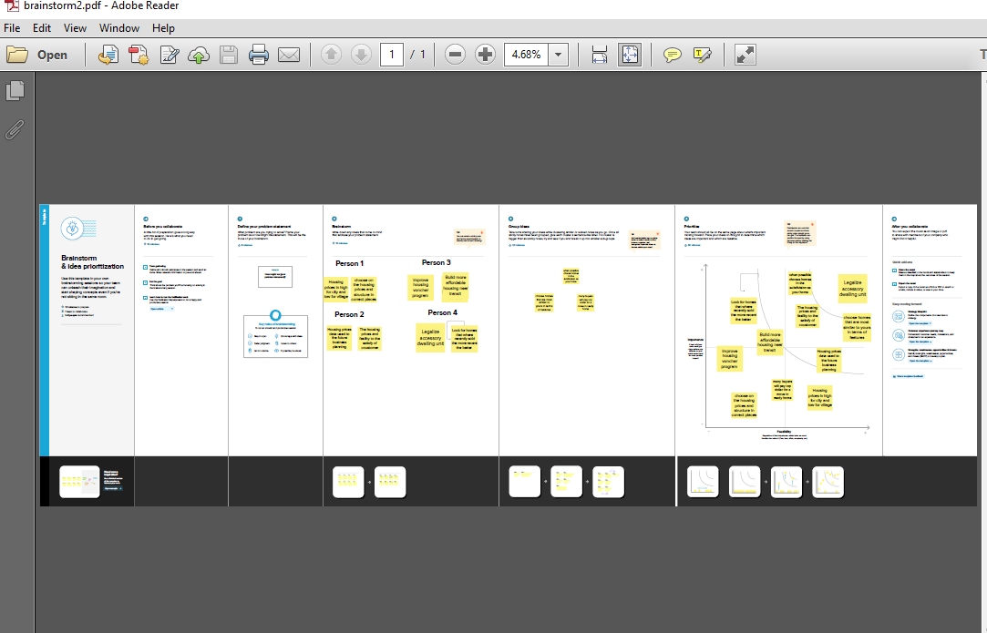

**Result** 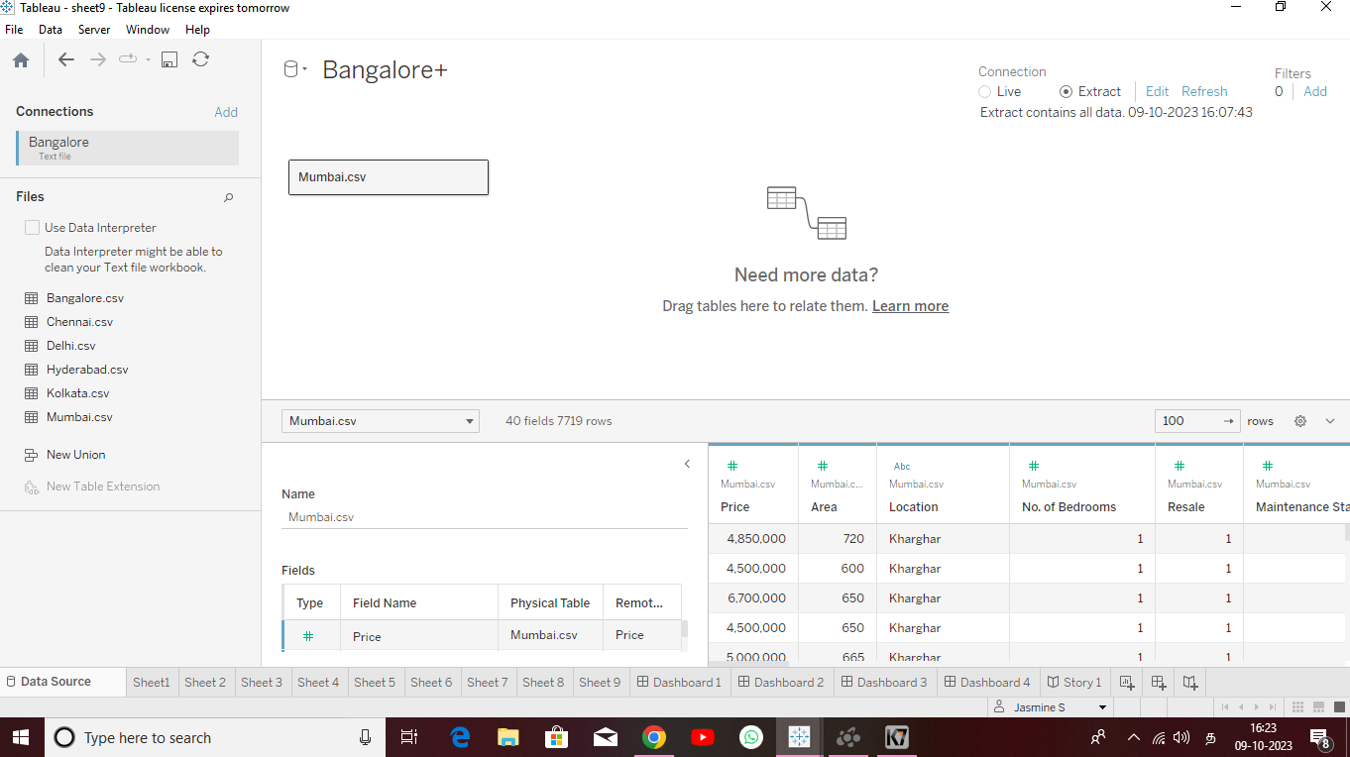

**Advantages**

Places to Eat and Shop.

Networking.

Medical Assistance and Care.

**Disadvantage**

Price Different.

Category of performance.

**Application**

House price prediction can help the developer determine the selling price of a house and can help the customer to arrange the right time purchase a house.

**Conclusion**

The estate agent first of all visits the house in order to value it and decide on an asking price with you.

**Future Scope**

India house prices grew 2.7% YoY in Jun 2023, following an increase of 1.8% YoY in the previous quarter. YoY growth data is updated quarterly, available from Mar 2011 to Jun 2023, with an average growth rate of 5.0%.